




Report On:

“Synchronous Sequential Circuits

&

Asynchronous Sequential Circuits”

Course Code: CSE-205

Course Name: Digital Logic Design

Submitted by:

Md. Hussain Anjum Ratul

Roll: 22102041

Reg: 10847

Supervised by:

HABIBA SULTANA

Assistant Professor

Dept. of Computer Science and Engineering

Jatiya Kabi Kazi Nazrul Islam University

Table of Contents

- Definition of sequential circuit --------------------------- 02

- Synchronous Sequential Circuits:
1.1 Basic design steps ------------------------------------------------------ 02
1.2 State table ---------------------------------------------------------------- 03
1.3 State assignment -------------------------------------------------------- 03
1.4 Summary of design steps ---------------------------------------------- 04
1.5 State-assignment problem --------------------------------------------- 04
1.6 One-hot encoding ------------------------------------------------------- 05
1.7 Mealy state model ------------------------------------------------------ 05
1.8 State Minimization ----------------------------------------------------- 06
1.9 Design of a Counter Using the Sequential Circuit Approach ---- 06
1.10 State diagram and state table for a modulo-8 counter ------------- 07

- Asynchronous Sequential Circuits:

2.1 Asynchronous behavior ------------------------------------------------ 08
2.2 Static hazards ------------------------------------------------------------ 09
2.3 Dynamic hazards -------------------------------------------------------- 10
2.4 Significance of hazard -------------------------------------------------- 11

Definition of sequential circuit:

In which the outputs depend on the past behavior of the circuit, as well as on the present values of inputs. They are called sequential circuits. In most cases a clock signal is used to control the operation of a sequential circuit; such a circuit is called a synchronous sequential circuit.

1. Synchronous Sequential Circuits

Synchronous sequential circuits are digital circuits that use clock signals to synchronize the flow of data. They are widely used in various applications, including computer systems, communication systems, and control systems. Here are the key topics related to synchronous sequential circuits:

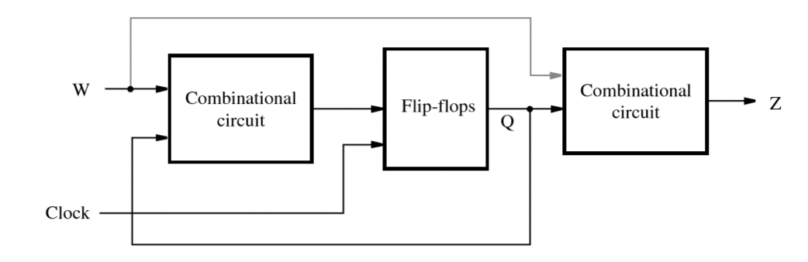
Fig1.1: The general form of a sequential circuit.

1.1 Basic Design Steps

Designing a synchronous sequential circuit involves several steps, including problem specification, state diagram construction, state table creation, state assignment, and circuit implementation.
We wish to design a circuit that meets the following speciﬁcation:
1. The circuit has one input, w, and one output, z.
2. All changes in the circuit occur on the positive edge of the clock signal.
3. The output z is equal to 1 if during two immediately preceding clock cycles the input w was equal to 1. Otherwise, the value of z is equal to 0.

1.2 State Table:

A state table is a tabular representation of the behavior of a sequential circuit. It shows the relationship between the present state, input, next state, and output of the circuit.
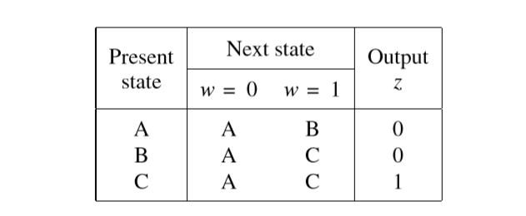
Fig 1.2: State table.

1.3 State Assignment:

State assignment refers to the process of assigning binary codes to different states in a sequential circuit. It is important to assign states in a way that minimizes the complexity of the circuit .
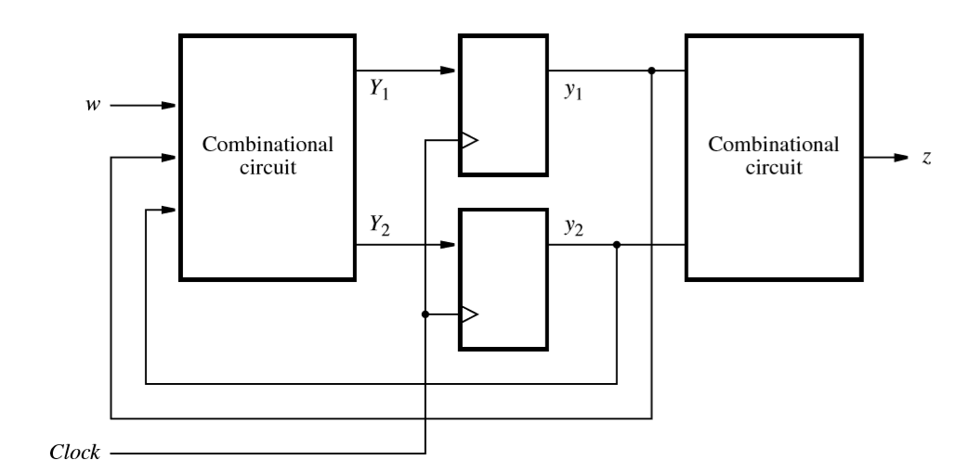

Fig 1.3: A general sequential circuit with input w, output z, and two state ﬂip-ﬂops.

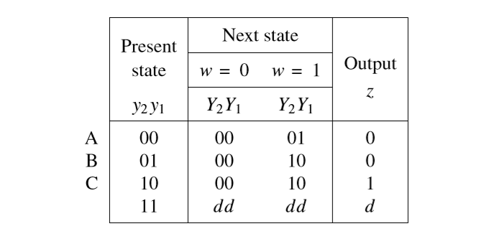
Fig1.4: State-assigned table corresponding to 1.3

1.4 Summary of Design Steps:

The design steps for synchronous sequential circuits can be summarized as follows:
Specification: Understand the desired circuit's specifications.
State Derivation: Define states using a starting point and input valuations, creating a state diagram to visualize transitions.
State Table: Convert the state diagram to a table or directly create it, outlining state transitions.
State Minimization: If needed, reduce the number of states through a minimization process to optimize the design.
State Assignment: Decide on the required state variables and perform assignment, considering different possibilities.
Flip-Flop Selection: Choose the appropriate flip-flop type and formulate logic expressions for next-state control and circuit outputs.
Implementation: Construct the circuit based on the derived logic expressions, completing the design process.

1.5 State-Assignment Problem

The state-assignment problem refers to the challenge of assigning binary codes to states in a way that minimizes the complexity of the circuit. Various techniques, such as one-hot encoding, can be used to solve this problem.

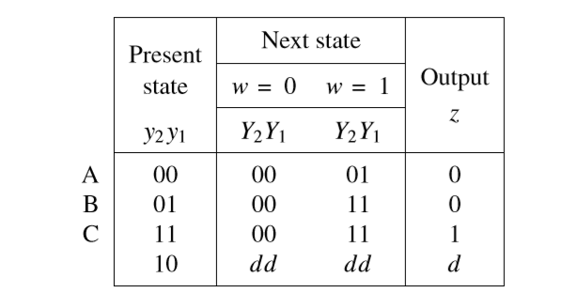

Fig 1. 5: Improved state assignment for the state table in Figure 1.2

Figure 1.5 gives one possible alternative. In this case we represent the states A, B, and C with the valuations y2y1 =00, 01, and 11, respectively. The remaining valuation, y2y1 =10, is not needed, and we will treat it as a don’t-care condition. The next-state and output expressions derived from the ﬁgure will be,

Y1 =D1 =w
Y2 =D2 =wy1
z =y2

1.6 One-Hot Encoding:

One-hot encoding is a state-assignment technique where each state is represented by a unique binary code. This technique simplifies the circuit design but may require more flip-flops.
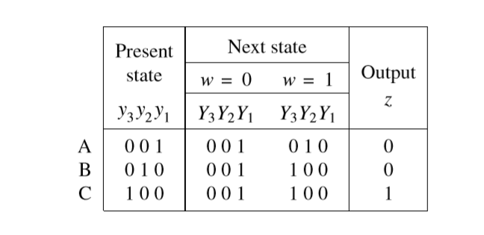
Fig 1.6: One-hot state assignment for the state table in Figure 1.2

1.7 Mealy State Model:

The Mealy state model is a type of synchronous sequential circuit where the output depends on both the present state and the input. It is represented by a state diagram and a state table.

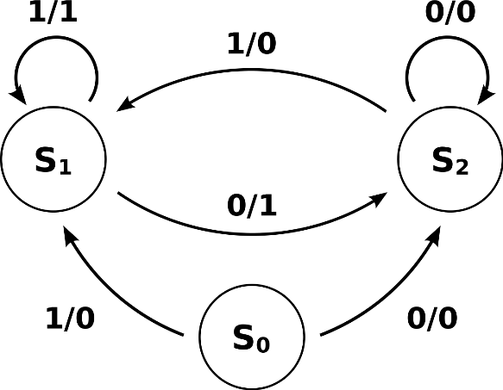

Fig 1.7: Mealy State Model

1.8 State Minimization:

State minimization is the process of reducing the number of states in a sequential circuit while preserving its functionality. This helps in simplifying the circuit design and reducing its complexity.

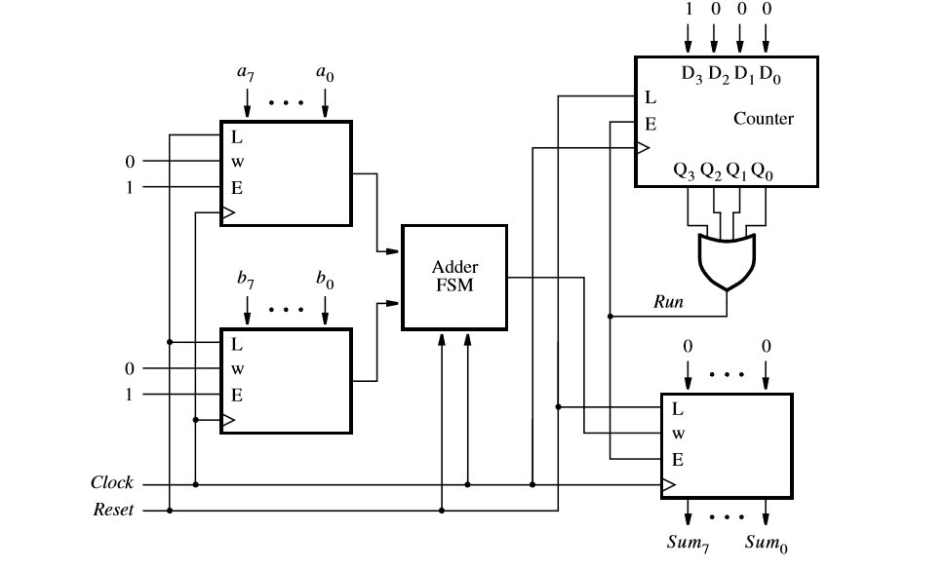
Fig 1.8: Circuit of state minimization

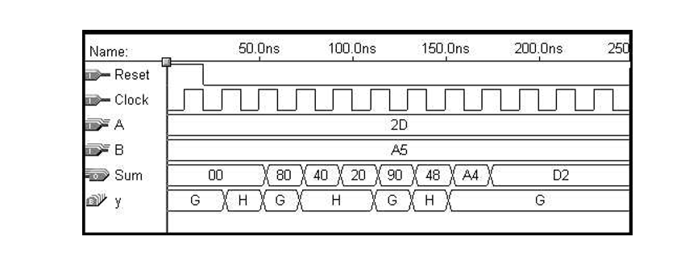
Fig 1.9: Simulation Results.

1.9 Design of a Counter Using the Sequential Circuit Approach:

Designing a counter using a sequential circuit approach involves creating a circuit that can increment or decrement a binary number (the counter) based on certain input signals (such as clock pulses) and produce an output representing the current count.

1.10 State Diagram and State Table for a Modulo-8 Counter:

A modulo-8 counter is a sequential circuit that counts from 0 to 7 and then repeats. It can be represented by a state diagram and a state table, which show the transitions between different states.

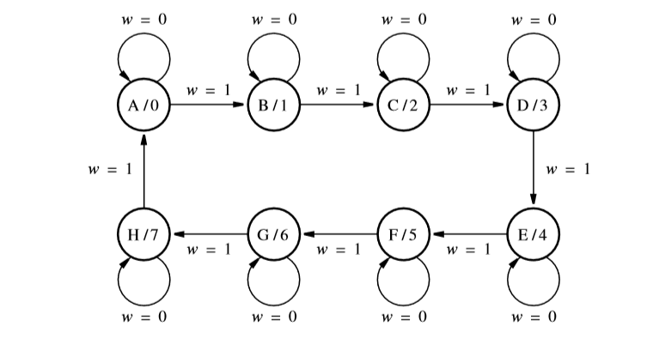

Fig 1.10: State diagram for the counter.

- Asynchronous Sequential Circuits

Asynchronous sequential circuits are digital circuits that do not rely on clock signals for synchronization. They change their state as soon as the inputs change. Here are the key topics related to asynchronous sequential circuits below

2.1 Asynchronous Behavior:

Asynchronous sequential circuits operate based on the immediate changes in their inputs, without the need for a clock signal. This allows for faster operation but can introduce challenges in terms of timing constraints and design complexity.
To introduce asynchronous sequential circuits, we will reconsider the basic latch circuit in Figure-2.1.

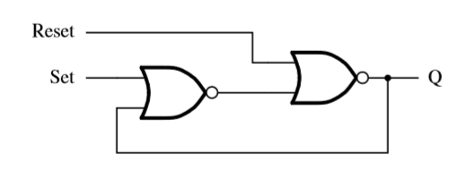
Fig 2.1: A memory element with NOR gates.

This Set-Reset (SR) latch is redrawn in Figure 2.2. The feedback loop gives rise to the sequential nature of the circuit. It is an asynchronous circuit because changes in the value of the output, Q, occur without having to wait for a synchronizing clock pulse. In response to a change in either the S (Set) or R(Reset) input, the value of Q will change after a short propagation time through the NOR gates.

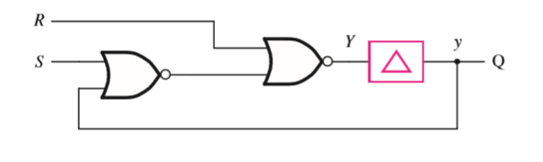
Fig 2.2: Circuit with modeled gate delay.

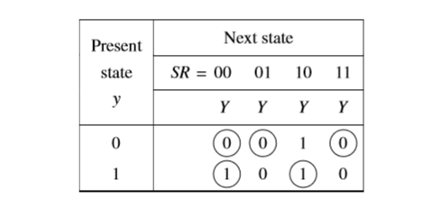
Fig 2.3: State-assigned table.

2.2 Static Hazards:

Static hazards are unwanted fluctuations in the output of an asynchronous sequential circuit due to timing differences in the inputs. They can occur when there are multiple transitions happening simultaneously or when there are delays in the circuit elements. Let’s consider the equation f =x1x2 +x1x3,

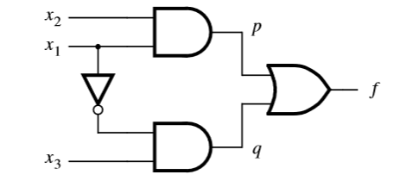
Fig 2.4: Circuit with a hazard.

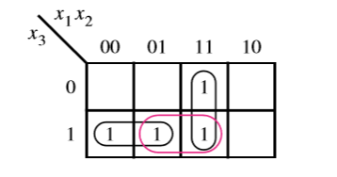
Fig 2.5: Karnaugh map.

Also consider the equation f =x1x2 +x1x3 +x2x3. This is a hazard free equation.

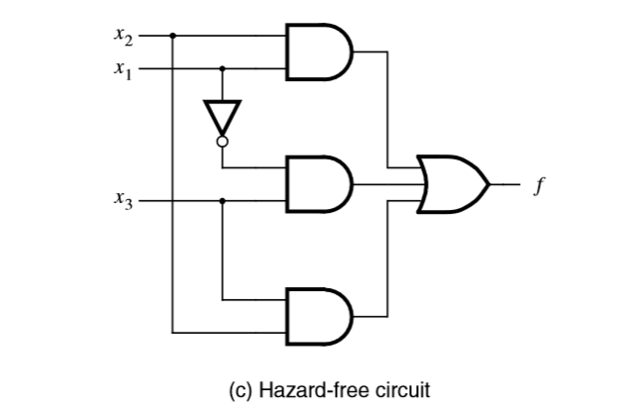
Fig 2.6: Hazard-free circuit.

2.3 Dynamic Hazards:

Dynamic hazards are similar to static hazards but occur when the output of an asynchronous sequential circuit fluctuates multiple times during a single transition. They can be caused by timing differences or glitches in the circuit elements. A dynamic hazard causes glitches on 0→1 or 1→0 transitions of an output signal. An example is given in Figure 2.77. Assuming that all NAND gates have equal delays, a timing diagram can be constructed as shown.

f =x1x2 +x3x4 +x1x4

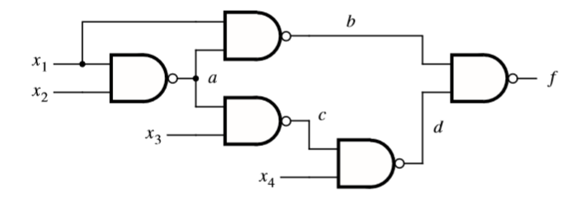

Fig 2.7: circuit of dynamic hazards

Adynamic hazard is caused by the structure of the circuit, where there exist multiple paths for a given signal change to propagate along. If the output signal changes its value three times, 0→1→0→1 in the example, then there must be at least three paths along which a change from a primary input can propagate. A circuit that has a dynamic hazard must also have a static hazard in some part of it.

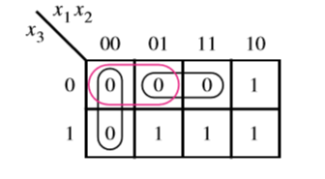

Fig 2.8: Karnaugh map.

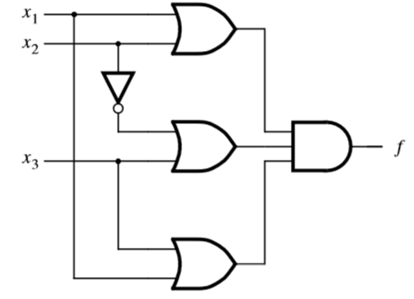

Fig 2.9: Hazard-free circuit

Dynamic hazards are encountered in multilevel circuits obtained using factoring or decomposition techniques. The designer can avoid dynamic hazards simply by using two-level circuits and ensuring that there are no static hazards.

2.4 Significance of Hazard:

Hazards in asynchronous sequential circuits can lead to incorrect or unpredictable behavior. They need to be carefully analyzed and addressed during the design process to ensure reliable and correct circuit operation. Let’s consider the fig 2.8 and 2.9 for better understanding that is also related to 2.10.
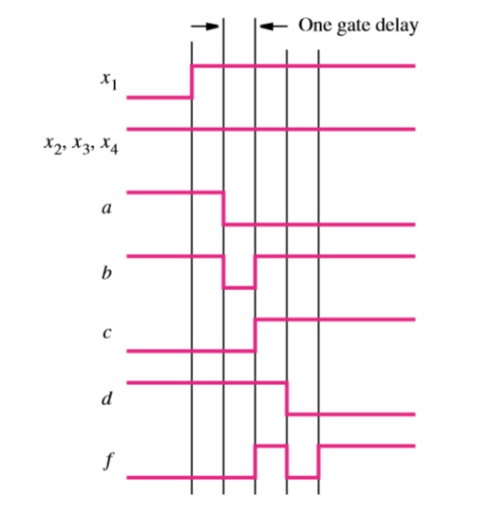

Fig 2.10: Timing diagram of f =x1x2 +x3x4 +x1x4

The output of a circuit depends solely on the values of the inputs. In synchronous sequential circuits the input signals must be stable within the setup and hold times of ﬂip-ﬂops. It does not matter whether glitches occur outside the setup and hold times with respect to the clock signal.

